““Pokemon Rock Salt & Brimstone:
03. Hello, Dean”

Date: July 26, 2014
Author: Mistina of the Cranky Ol’ Fangirls
Beta: Stormlyht
Series: Supernatural (Pokemon AU)
Pairing(s): Dean/Castiel
Spoilers: You just need to know who Cas is and you’re good.
Length: 1,149 words
Rating: G
Summary: “Dean Winchester, now a Pokemon Master, is found by Castiel. 10 years later. 10 FRIGGIN’ YEARS!!!”
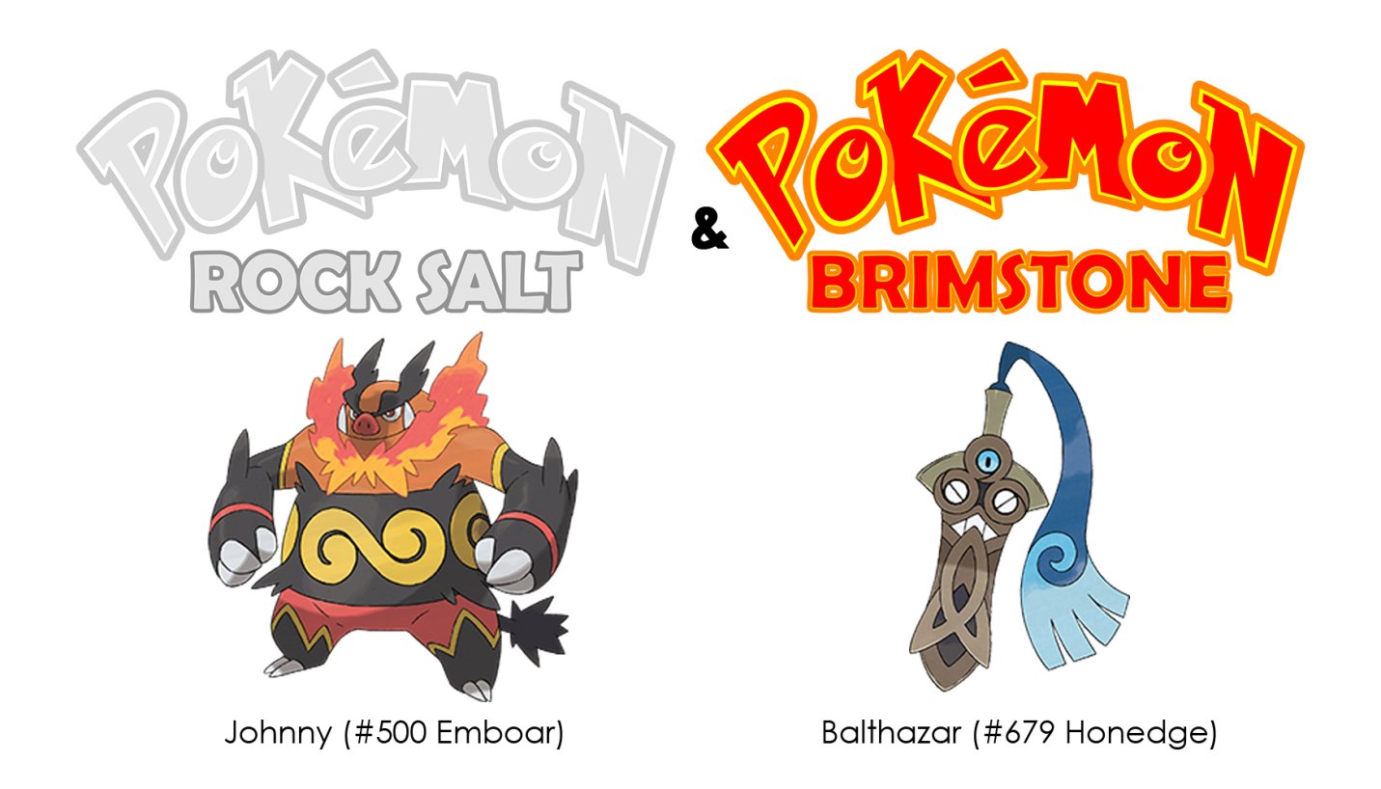
They were lost.
They were so very, very lost.
Hearing his Emboar squeal happily, something Dean hadn’t heard since Johnny was a wee little Tepig, should had tipped him off to the change in circumstance at the very least. Had he not been so deeply engrossed in not being lost anymore, he would have noticed the strangeness of that sound and looked up.
“Quiet, dude!” Dean barked at his Pokemon without looking up from the crinkled and folded open paper he was scrutinizing. “I’m trying to read this friggin’ map! Stupid Stanford City is stupidly far—”
“Hello Dean.” A voice suddenly spoke up, the gravelly tone familiar.
“Holy f—” Dean whipped around to find himself nose to nose with the man he hadn’t seen since his childhood. “Cas?” he whispered incredulously, heart pounding.
“Cas?” the legendary trainer, Castiel, tilted his head owlishly in confusion.
“You friggin’ jerk!” Dean pushed Cas roughly, ignoring the embarrassing question. “Where the Hell have you been all this time?! 10 years, man! 10 friggin’ years, you son of a b—”
Balthy, Castiel’s currently sheathed Honedge, chirped it’s anger but Cas put a calming hand on the hilt. “I told you before I left, Dean. There was work for me to do—”
“Yeah, you said you had stuff to do. I remember.” He rolled his eyes at the obvious answer to the obvious portion of his question. “But I also remember you saying that you’d come when I needed you! But not once in 10 friggin’ years did you come. Not once—”
“You never needed my assistance, Dean. Though a little unorthodox at times, you handled all of life’s obstacles—”
“Assistance?!” Dean sputtered and words escaped his mouth in the form of a growl before he could stop them. “I didn’t need your assistance, I needed you—”
A stunned silence fell over them, emphasized by the rustling of the tall grass lining the road and the faint cacophony of the insects dwelling there.
The longer the silence stretched, the redder Dean’s ears became.
Emboar burst into a fit of deep throaty chuckles once his trainer turned tomato red, completely flushed with embarrassment.
Dean glared daggers at his backstabbing Pokemon, but its intensity was enfeebled by the panic welling up in his chest, suffocating him and threatening to burst through his rib cage.
The words were spoken. They were out in the open. Johnny had heard them. Balthy had heard them. Cas… Dean couldn’t take them back, not now, but he couldn’t move forward with those words flitting about. He was trapped.
"Dean…" Castiel said softly, taking a cautious step forward.
Dean startled and looked like he was about to hyperventilate. He looked so terrible that Johnny wasn’t laughing anymore.
"Dean!" Castiel instantly closed the gap between them to grab Dean firmly by the shoulders. "Dean, relax!"
"Let go, you son of a bi —”
"Dean! Please calm down so I can talk!"
Dean was stunned into silence and stillness at Castiel’s raised voice, having never heard it before and having never expected too. Once Cas had Dean’s full attention, he took a breath and smiled softly.
"I have been watching over you, Dean. Always." His smile grew wider and wider as he spoke, brilliant with genuine affection. "There were many times I could barely restrain myself from flying down to aid you, despite knowing you were more than capable of resolving the situation. And you did, you made me so proud, Dean. But even so I wanted to…”
“Why didn’t you?!” Dean yelled, pulling away and breaking out of Castiel’s grip.
“I wasn’t allowed.”
“Allowed?!”
“I wasn’t allowed to see you until…” his right hand flexed at his side. Dean, upon seeing this, unconsciously rubbed his left shoulder.
"Why?” the reason he always wore a tank top was to reveal the hand print shaped birthmark there.
“I couldn’t interfere with your natural development. You had to become… you.”
Dean snorted, “You are way too late to worry about that, Cas—”at Castiel’s horrified look he quickly elaborated”—no, no, no! You didn’t screw up! It was for the best, Cas.”
Confused, Castiel tilted his head in an owlish manner Dean hadn’t seen since he was kid.
“You changed my life, dude,” he said with a fond laugh.
“Finding a long lost hero gave me hope and confidence.” Dean blanched at Castiel’s recitation of words he’d never spoken aloud. “My anger at his absence gave me strength and drive. This feather gave me a goal.”
Everyone was shocked speechless.
Not for long, though.
Johnny fell to the ground hard, wracked with peals of laughter.
“W-W-WHERE IN THE HELL DID YOU HEAR THAT?!!” Dean exclaimed in horror, beet red with humiliation.
Even Balthy was chirping his laughter, for crying out loud.
“I watched over you, Dean,” Castiel deadpanned, seemingly unaware of Dean’s embarrassment, “and so I heard you too.”
“B-but I didn’t say any of that!!!” Dean cried out desperately.
“You mouthed it as you wrote it down in your journal.”
They fell silent though their Pokemon were still cackling away.
“You heard… everything?”
“Yes.”
“And you still didn’t come?!”
“Well…” Castiel hesitated. He wasn’t saying no.
“Well what?!” Dean couldn’t believe it. Cas was, honest to God, flustered. Normally the guy responded without a thought. He knew all, he told all—
Unless…
“Wait. Those times when I came close to giving up and… And I had those dreams where you lectured me a-and comforted me…”
Castiel didn’t answer, but his burning cheeks told Dean everything he wanted to know.
“That was you?!! Like, the real you and not my dream you?!”
Cas raised a brow. “’Dream’ me?”
Dean flushed. “What, so you weren’t watching my dreams?”
Castiel shook his head. “I only entered your dreams when I couldn’t keep myself from flying down to comfort you in person. But when I did, I needed help from a friend…”
Dean was so busted.
It just wasn’t his day.
“You dreamt about me?”
At this point their Pokemon exchanged looks and rolled their eyes when they realized their trainer’s feelings were mutual. Amused, and a little frustrated, they both huffed ‘Humans!' in their respective tongues.
“So you couldn’t see my dreams!” Dean abruptly changed the topic for a tiny moment of reprieve. “You heard me? Every time I… I… called for you?”
“Yes. Until now, I couldn’t come.”
“’Until now?’ Do you mean…?”
Castiel position himself so that he was nose to nose with Dean, whose breath hitched at the sudden proximity. It wasn’t unwelcome, just new.
“Why…” Cas mumbled.
“What?” Even if he wasn’t currently distracted, the question was awfully vague.
“Why the tank tops, Dean?” Castiel gazed deeply into Dean’s eyes, squinting in their sincerity. “Why the feather? Why ‘Cas’?”
To his everlasting shame, Dean not only blushed, he blushed fiercely.
“B-Because… I… I was… waiting….”
Castiel carefully placed his right hand on Dean’s left shoulder. It fit perfectly atop the birthmark.
“The cycle has begun. Are you ready, Dean?”
“Only if you don’t leave,” he replied without hesitation.
Castiel smiled brilliantly, his hand still on Dean’s shoulder.
“Agreed.”
THE END

